**IDEATION PHASE**

**Brainstorm & Idea Prioritization**

|  |  |
| --- | --- |
| **Date** | **25-06-25** |
| **Team ID** | **LTVIP2025TMID31548** |
| **Project Name** | **Field Service Workorder Optimization** |

**Brainstorm & Idea Prioritization Template:**

Brainstorming fosters a collaborative environment where team members can freely contribute creative ideas to optimize field service work order processes. The goal is to prioritize innovative, out-of-the-box solutions that enhance efficiency, reduce costs, and improve customer satisfaction. This template guides your team through the ideation and prioritization process, whether in-person or remote, to develop actionable solutions for work order optimization.

**Step-1: Team Gathering, Collaboration and Select the Problem Statement**

* **Objective**: Assemble the team, define roles, and select a clear problem statement to address inefficiencies in field service work order management.
* **Problem Statement**: Current field service work order processes suffer from delays, miscommunication, and inefficient resource allocation, leading to increased operational costs and reduced customer satisfaction.
* **Activities**:
  + Gather cross-functional team members (e.g., field technicians, dispatchers, IT specialists, and customer service representatives).
  + Use collaborative tools (e.g., Mural, Miro) for virtual or hybrid brainstorming sessions.
  + Define the scope: Optimize scheduling, routing, and task allocation for field service work orders.
  + Assign a facilitator to guide discussions and a scribe to document ideas.

**Step-2: Brainstorm, Idea Listing and Grouping**

* **Objective:** Generate a high volume of ideas to address the problem statement, then group similar ideas for clarity.
* **Process:**
  + Conduct a 15–20 minute brainstorming session where all ideas are welcome, no matter how unconventional.
  + Use a timer to keep the session focused and encourage rapid idea generation.
  + List ideas on a digital whiteboard or sticky notes (virtual or physical).
  + **Group similar ideas into categories such as:**
    - **Scheduling Optimization**: Automated scheduling, real-time updates
    - **Routing Efficiency**: GPS-based routing, traffic-aware algorithms.
    - **Resource Allocation**: Technician skill matching, inventory management.
    - **Customer Communication**: Automated notifications, customer portals.
    - **Data Analytics**: Predictive maintenance, performance dashboards.

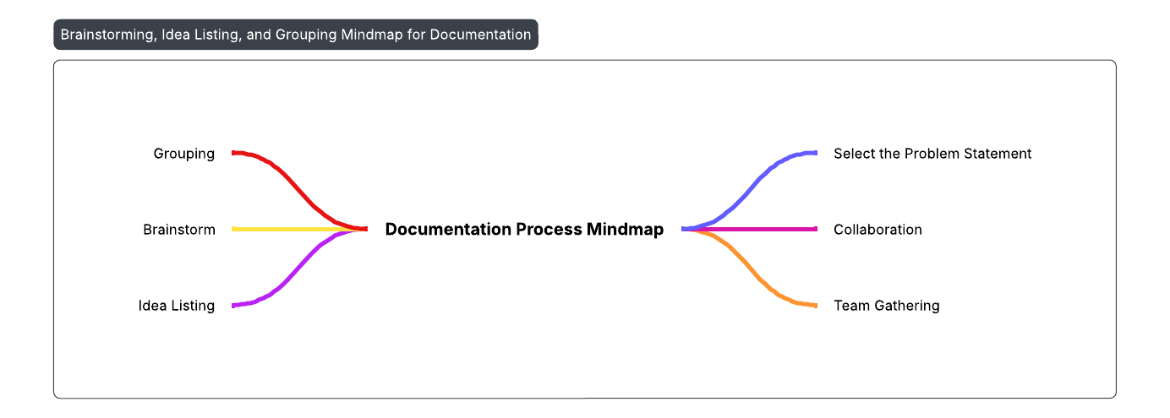

**Step-3: Idea Prioritization**

* **Objective**: Evaluate and prioritize ideas based on feasibility, impact, and alignment with project goals.
* **Process**:
  + Use a prioritization matrix to score ideas (e.g., Impact vs. Effort or Cost vs. Benefit).
  + Assign scores (1–4) for each idea based on:
    - **Impact**: How significantly does it improve efficiency or customer satisfaction? (1 = Low, 4 = High)
    - **Feasibility**: How practical is it to implement within 6–12 months? (1 = Difficult, 4 = Easy)
    - **Cost**: What is the estimated cost of implementation? (1 = High, 4 = Low)

**Empathy Map**

